**Dangers of Grass Seeds**

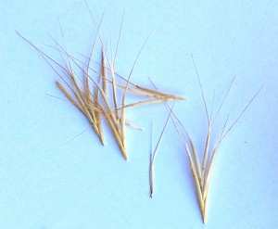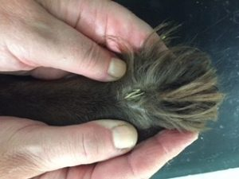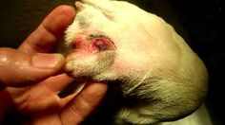

**Prevention**

Avoid long grass in the warmer months. Check your dog after a walk – run your fingers through their fur and check inside the ears, between the toes, and in the mouth and eyes. Ensure your dog is well groomed, especially around the ears and paws.

**What are they?**

Grass seeds are carriers of bacteria and once they penetrate the skin, infection is inevitable. If left untreated, this infection could spread, or the seed could move around in the body and cause severe internal damage. Once this happens, there is no treatment plan other than surgery to find them and remove them.

**Symptoms:**

There are many different places that grass seeds like to attach themselves to and here is a table to show the various symptoms of grass seed infection in each area as well as possible complications:

|  |  |  |
| --- | --- | --- |
| **Location** | **Symptoms** | **Possible Complications** |
| **EARS** | * Head shaking * Redness and painful to touch * Holding the head to one side * Loss of balance | * Ear infection * Rupture of the ear drum * Permanent loss of hearing or balance |
| **EYES** | * Swollen, red eye * Excessive tear production * Rubbing at the eye | * Penetration of the eye * Ulceration of surface of the eye * Worst cases – removal of the eye if damage severe enough |
| **PAWS** | * Excessive licking between toes * Red, swollen area on foot * Hair matting * Limping or holding up leg | * Migration of the seed up the leg, between ligaments and tendons, possibly into joints |
| **NOSE** | * Repeated sneezing * Rubbing face on ground * Difficulty breathing * Bloody discharge from one nostril | * Damage to airways * Migration of the grass seed into the lungs – this is often life threatening |