HOT WEATHER ADVICE

If you're planning to be out and about with your dog this summer, it's important to know how to make sure you dog stays happy and healthy.

Here are five steps to a safe summer:
- Plan your walkies
Walk your dog in the early morning or late in the evening when temperatures are cooler so they will be at reduced risk of heatstroke – be particularly careful if your dog is unfit, obese or suffers from breathing difficulties.
- Do the Seven Second Test
Tarmac and pavements can get very hot in the sun – check it with the back of your hand before letting your dog walk on it so they do not burn their paws. Try the 'seven-second test'; if it's too hot for your hand, it's too hot for your dog's paws.
- Check dogs are welcome
If you're planning a day out, check whether dogs are welcome at the visitor attractions you plan to visit. Some public parks and beaches may have restrictions in place over summer, so do check before travelling. If dogs are not permitted, please make sure you arrange for a pet sitter or kennels or choose a dog friendly alternative attraction.
- Provide shade and water
Make sure your dog has access to shade and plenty of fresh water throughout the day.
- Don't let them get burnt
Don't let your pet get sunburnt – use pet-safe sun cream on exposed parts of their skin such as the tips of their ears and nose and avoid direct sunlight where you can White short haired dogs are particularly at risk to sunburn – even on their tummies!! Ask your vet for further advice if needed.
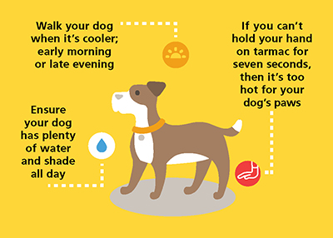

What to do if your dog overheats
If dogs are too hot and unable to reduce their body temperature by panting, they will develop heatstroke which can be fatal. Some dogs are more prone to heatstroke than others – such as very old or young dogs, those with thick heavy coats or those with short, flat faces (such as Pugs and Boxers). Dogs with certain diseases or on some types of medication are also more prone to heatstroke.

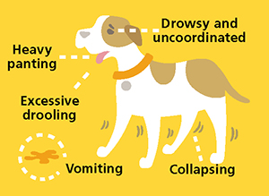

What are the symptoms of heatstroke in dogs?

- Panting heavily
- Drooling excessively
- Appears lethargic, drowsy or uncoordinated
- Vomiting
- Collapsing
If your dog is showing any of the signs, please follow emergency dog first aid and contact your nearest vet if necessary.

Emergency first aid for dogs with heatstroke
For the best chance of survival, dogs suffering from heatstroke urgently need to have their body temperature lowered, but this needs to be done gradually or they can go into shock.
If your dog has collapsed, call a vet immediately as they may advise attending as a matter of emergency rather than starting treatment yourself.
In milder cases, you can follow these First Aid steps to start lowering your dog's temperature:

- Move the dog safely to a shaded and cool area

- Immediately start pouring small amounts of room temperature (not cold) water onto the dog's body (cold water may cause shock). If possible, you can also use wet towels or place the dog in the breeze of a fan. If using wet towels, be sure to re-apply water regularly and not to keep the dog constantly covered – sometimes this can heat them up instead of cooling them down.

- Allow the dog to drink small amounts of room temperature water.

- Continue to pour small amounts of room temperature water onto the dog until their breathing starts to settle but not so much that they start to shiver.

- Once the dog is starting to get cooler and their breathing is settling down, call the nearest vet so they can be checked over.

Dogs die in hot cars

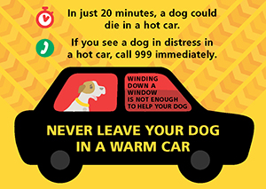

Think twice about any car trips with your dog - avoid congested roads or busy times of day when they could overheat in the car if you are caught up in traffic. Winding down a window is not enough to help your dog. If driving with your dog plan your journey considering cooler times of the day and places to take breaks.
In just 20 minutes, a dog could die in a hot car. Winding a window down is not enough to help your dog – never leave your dog in a warm car.
If you see a dog in distress in a hot car, call 999 immediately and ask advice as to whether you can break into the car to rescue the dog.

A DOG GOING WITHOUT A WALK FOR ONE DAY WON’T KILL THEM, HOWEVER GOING OUT FOR A WALK IN HOT WEATHER - MIGHT!!!!

DON’T BE AN IDIOT.

BE PREPARED, BE RESPONSIBLE

